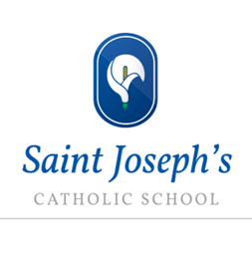
HA Enrichment Menu KS4

Department Name | Activities Available
Cross-curricular (in partnership with South Wilts Grammar School) | SWAT Challenge Ambassadors Day which takes place annually with grammar schools from the South West and is open to Year 10 HA pupils. The day starts with an address from a motivational speaker and then the students have the opportunity to move around a variety of structured tasks designed to challenge them. Last year, the Escape Room activity was definitely the most challenging!
English | Higher Ability Students are encouraged to read widely around the topics and also Challenge 9, a new initiative to challenge students to aspire to 9.  HOT club (Higher Order Thinking Skills) which will be open to HA year 9 and 10. In the club a student will have 5 minutes to present on a topic of their choice- literally can be anything. The only requirement is at the presentation it must end with a debate question. The question is then opened to the floor and is debated among club members. It is a great way for students to research and present on topics which matter to them.
Maths | KS4 UK Mathematics Intermediate Maths Challenge for Years 9-11 national higher level problem solving competition.  KS4 Maths Feast Enrichment Morning (via Further Maths Support Programme) with motivational speaker
Science | KS4 Students vs Teachers – the Great Debate!  Annual Biology Challenge
RE | Candle Conference for all KS4 HAers  Catenian Public Speaking Competition
MFL: Spanish  MFL: French | Spanish Theatre Company Trip  Opportunity to become MFL Prefects & run MFL clubs, leading activities during International Week
Geography | Planning and delivery of orienteering: application of map skills in our location for KS3 activity
History | A number of students have been working closely with Salisbury Museum to advise and engage with the development of new displays, within a set of 10 workshops at Museum after school and at lunchtime. This has been open to all year groups.
Sociology | Debate Club!
PE | Extensive programme for HA pupils, rota involving duties, leading house comps and officiating opportunities; HA pupils as coaches/referees in extra-curricular clubs; fixtures across all sports
Music | Group music activities will be on hold until the current situation changes  Samba band  School windband/orchestra; Rock band club; Choir; An A Capella group; Keyboard club; An annual house music competition ;
Food Technology | Masterchef: all Food Tech HA will be strongly recommended to participate
Art and Design | Invitation to Art Club every Wednesday

