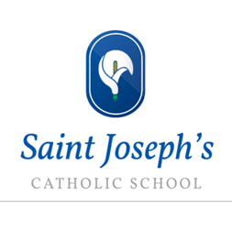
HA Enrichment Menu KS3

Department Name | Activities Include:
English | For KS3: BBC School's News Report: for HA students in years 8 and 9 only.
Maths | KS3 UK Mathematics Trust Junior Maths Challenge for Years 7&8; national higher level problem solving competition.
Science | Year 8 Eye Ball dissection  KS3 Problem Solving Challenges 1&2
RE | Chaplaincy meetings every Tuesday.  Fair Trade Group
MFL: Spanish  MFL: French | Extra optional learning tasks & MFL clubs
Geography | Orienteering: application of map skills in our location
History | World War II Artefact Trawl: finding out more about WWII through investigating artefacts from a museum This will be on hold until Spring 2021
PE | Identified opportunities to lead sessions in extra-curricular clubs and working with HA KS4.
Music | Group music activities will be on hold until the current situation changes  School windband/orchestra; Rock band club; Choir; An A Capella group; Keyboard club; An annual house music competition
Food Technology | Masterchef: all Food Tech HA will be strongly recommended to participate
Art and Design | HA booklets for all HA learners  Free Open Studio to work on HA activities  Christmas competition

