St Joseph’s Carol Service
Thursday 15th December 2022

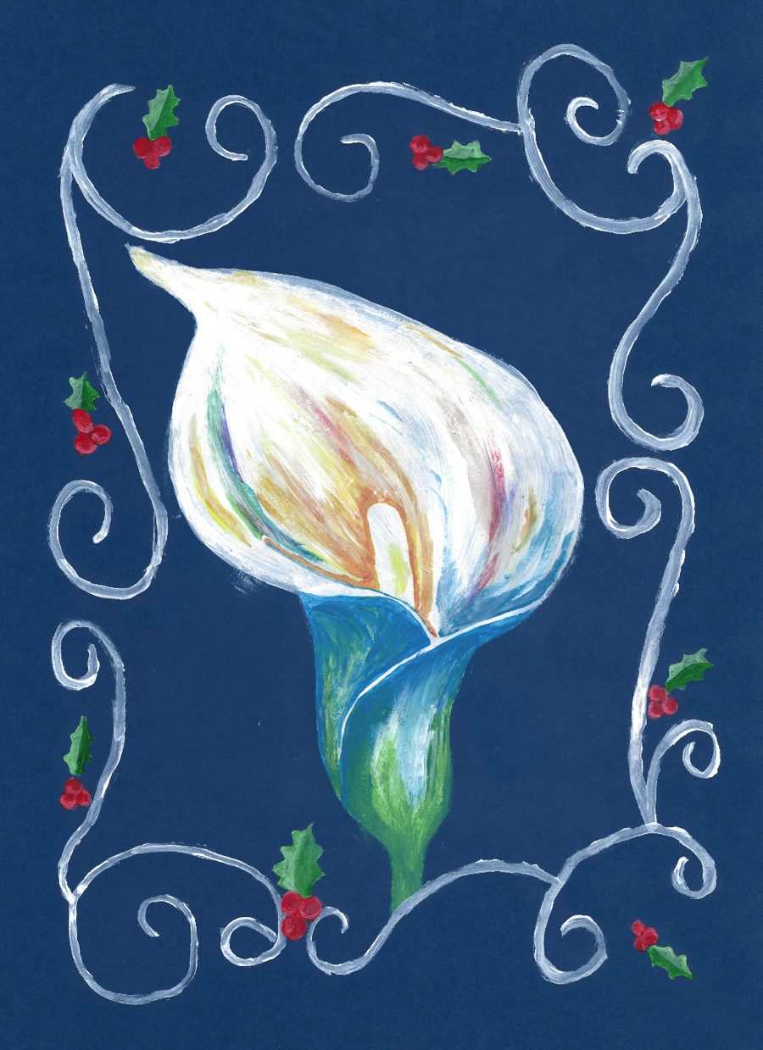

Once in Royal David’s City

1st Verse solo, unaccompanied | Once in royal David’s city,  Stood a lowly cattle shed,  Where a Mother laid her baby,  In a manger for His bed,  Mary was that Mother mild,  Jesus Christ her little child
Please stand  and sing if you  are able | He came down to earth from heaven  Who is God and Lord of all  And his shelter was a stable  And his cradle was a stall  With the poor and meek and lowly,  Lived on earth our Saviour Holy.  And, through all His wondrous childhood,  He would honour and obey,  Love, and watch the lowly Maiden,  In whose gentle arms he lay  Christian children all must be  Mild, obedient, good as He.  And our eyes at last shall see him,  Through His own redeeming love,  For that child so dear and gentle,  Is our lord in heav’n above.  And He leads His children on  To the place where He is gone.  Not in that poor lowly stable,  With the oxen standing by,  We shall see Him, but In heaven,  Set at God’s right hand on high;  When like stars His children crown’d  All in white shall wait around.

Introduction | Head Pupils
Opening Prayer | Father Joseph Columba
First Reading – Isiah 9:2 | A Ransome

Away in a Manger

Please stand and sing if you are able

Away in a manger, no crib for a bed,
The little lord Jesus laid down his sweet head.
The stars in the bright sky looked down where he lay,
The little lord Jesus asleep on the hay.

The cattle are lowing, the baby awakes,
But little lord Jesus no crying he makes.
I love you lord Jesus; look down from the sky,
And stay by my side until morning is nigh.

Be near me lord Jesus I ask you to stay
Close by me for ever, and love me, I pray.
Bless all the dear children in your tender care,
And fit us for heaven, to live with you there.

Music Piece | H Smith
Second Reading –  Luke 1:26–38 | I Watson & N Neville
Prayer | C Gilbertson

O Little Town of Bethlehem

Please stand and sing if you are able

O little town of Bethlehem,
How still we see thee lie.
Above thy deep and dreamless sleep
The silent stars go by;
Yet in thy dark streets shineth
The everlasting Light.
The hopes and fears of all the years
Are met in thee tonight.

For Christ is born of Mary,
And, gathered all above
While mortals sleep, the angels keep
Their watch of wond'ring love.
O morning stars, together
Proclaim the holy birth,
And praises sing to God the King,
And peace to men on earth.

How silently, how silently
The wondrous gift is giv'n!
So God imparts to human hearts
The blessings of his heav'n.
No ear may hear his coming;
But in this world of sin,
Where meek souls will receive him, still
The dear Christ enters in.

Music Piece | B James & A Ransome
Third Reading –  Luke 2:8–20 | B James & M Morrisey-Leggett
Prayer | C Gilbertson
Silent Night

Please stand and sing if you are able

Silent night! Holy night!
All is calm, all is bright,
Round yon virgin mother and Child!
Holy infant so tender and mild,
Sleep in heavenly peace,
Sleep in heavenly peace.

Silent night! Holy night!
Shepherds quake at the sight!
Glories stream from Heaven afar,
Heavenly host sing Alleluia;
Christ the Saviour is born,
Christ the Saviour is born.

Silent Night! Holy night!
Son of God, love’s pure light;
Radiance beams from Thy holy face,
With the dawn of redeeming grace,
Jesus, Lord, at Thy birth,
Jesus, Lord at Thy birth.

Final Advent Poem | Read by Mr R. Rooney, Assistant Headteacher
Music Piece | Performed by Mr D. Inglis & Year 8 Pupils
Final Reading –  John 1:1-19 | Mr A. Bazen, Deputy Headteacher

Oh, Come All Ye Faithful

Please stand and sing if you are able

O come, all ye faithful, joyful and triumphant!
O come ye, O come ye to Bethlehem;
Come and behold him
Born the King of Angels:
O come, let us adore Him,
O come, let us adore Him,
O come, let us adore Him,
Christ the Lord.

God of God, light of light,
Lo, he abhors not the Virgin's womb;
Very God, begotten, not created:
Chorus

Sing, choirs of angels, sing in exultation,
Sing, all ye citizens of Heaven above!
Glory to God, glory in the highest:
Chorus

Yea, Lord, we greet thee, born this happy morning;
Jesus, to thee be glory given!
Word of the Father, now in flesh appearing!
Chorus

Prayer and Blessing | Father Joseph Columba

Goodnight and blessed Advent on behalf of Mrs R Ridley, Headteacher and from Mr Bazen, Deputy Headteacher

With special thanks for all those staff and pupils involved

Please join us for Mulled Wine and Mince Pies following the Service kindly provided for us by the Friends of St Joseph

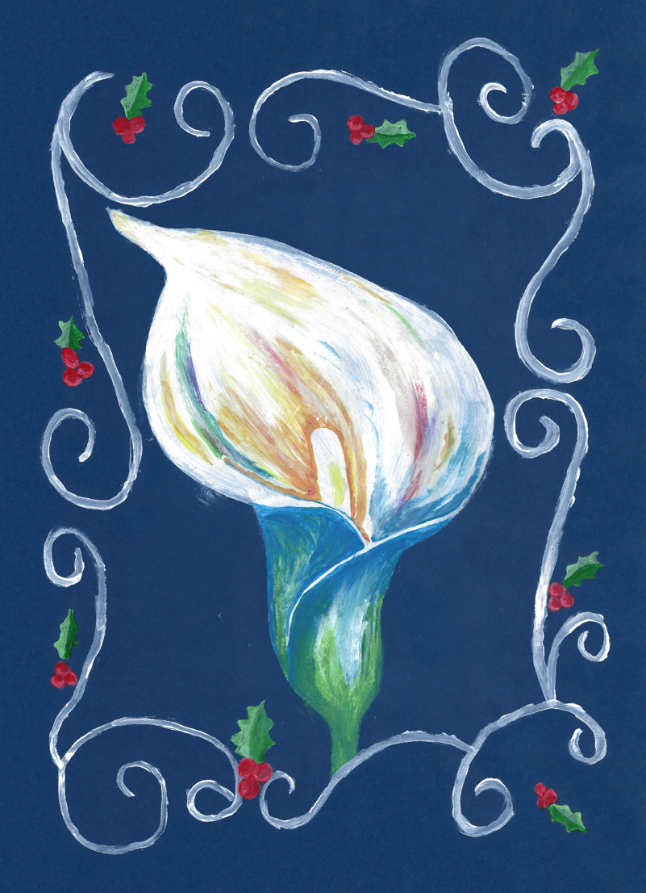

Artwork designed by B James

