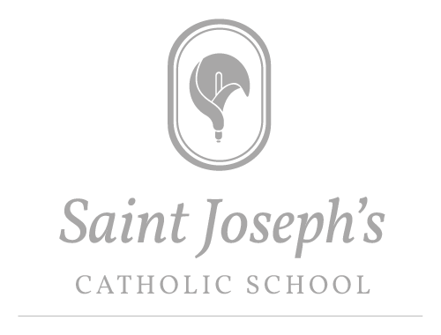

Head teacher: Mrs R A Ridley BA (Hons) NPQH

School Information Form

(SIF)

Year 7 Applications for Intake in September 2024

Name of Pupil: ____________________________________ (Block Capitals)

PLEASE RETURN THIS FORM TO:
The Head teacher
Saint Joseph’s Catholic School
Church Road
Laverstock
Salisbury
SP1 1QY

PLEASE RETURN THIS FORM TO SCHOOL BY: 31st October 2023

Please do remember that this form is in ADDITION to the form that is returned to the Local Authority (LA)

Please complete all sections of this form in BLOCK LETTERS
Please refer to the Admissions Policy when completing this form (Please note you can access the Admission Policy via the school website)

Pupil information:

Pupil surname:

Pupil first name:

Pupil date of birth:

Religious denomination:

 | Please enclose, where possible, a supporting letter/reference from a Minister or Religious Leader
Is the applicant a baptised Catholic? | YES |  | NO
 | Please enclose a photocopy of the Baptism certificate and a reference from your Parish Priest
Is the pupil in public care, or a previously look after child? | YES |  | NO
 | Please enclose a photocopy of the Special Guardianship / Residence Order / Adoption Certificate
Names of sisters or brothers who currently attend Saint Joseph’s Catholic school | Name: |  | Year Group:
 | Name: |  | Year Group:
 | Name: |  | Year Group:
 | Please be aware that a sibling in Year 11 will not count as a current pupil
Address:

Name of current Primary school:

Any other relevant information relating to the Admissions Policy:
Supporting Information:

Parents/Guardians information: | Father’s name:
 | Address:
 | Contact telephone number:
 | Email address:
 | Religious denomination:
 | Mother’s name:
 | Mother’s address:
 | Contact telephone number:
 | Email address:
 | Religious denomination:
Signed (Parent/Guardian): |  |  | Date:
Saint Joseph’s is a Voluntary Aided school. The admission authority of the school is the Governor’s Admission Panel. You have the right of appeal once the Panel has made its final decision. Details of the appeal process can be obtained from the school.

Failure to return this form may result in your application being placed in a lower category than that to which you are entitled

In compliance with the General Data Protection Regulation (GDPR) and the Data Protection Act 2018, we wish to ensure that you are aware of the purpose for which we collect and process the data we have asked you to provide on this form.
- We are St Joseph’s Catholic School,(VA) Church Road, Laverstock, Salisbury SP1 1QY
- Being a Catholic education provider, we work closely with the School’s Diocesan Authority, the School’s Trustees, the Local Authority, the Catholic Education Service and the Department for Education, and may share the information you provide on this application form if we consider it is necessary in order to fulfil our functions.
- The person responsible for data protection within our organisation is Kathryn Sanders at Romero Services and you can contact them with questions relating to our handling of the data. You can contact them by e-mail at dpo@romeroservices.co.uk
- We require the information we have requested for reasons relating to our functions as the admission authority of the School.
- It is necessary for us to process personal data for the performance of a task carried out in the public interest or in the exercise of official authority vested in the controller (Article 6(1)(e) of the GDPR).
- To the extent that you have shared any special categories of data this will not be shared with any third parties except as detailed in paragraph 2 above, unless a legal obligation should arise.
- It is necessary for us to process special category data for the performance of a task carried out in the public interest or in the exercise of official authority vested in the controller (Article 6(1)(e) of the GDPR). Additionally, processing is necessary for reasons of substantial public interest on the basis of Union or Member State law which is proportionate to the aim pursued and which contains appropriate safeguards (Article 9(2)(g) of the GDPR).
- If the application is successful, the information you have provided on this form will be migrated to the School’s enrolment system, and the data will be retained and processed on the basis of the School’s fair processing notice and data protection policies which apply to that data.
- If the application is unsuccessful, the application form and any documents submitted in support of the application will be destroyed after a period of 12 months. The school may keep a simple record of all applications and their outcome as part of their permanent archives in accordance with the School’s data retention policy.
- To read about your individual rights you can refer to the School’s fair processing notice and data protection policies.
- If you wish to complain about how we have collected and processed the information you have provided on this form, you can make a complaint to our organisation by referring to our complaints procedure, available on the school website. If you are unhappy with how your complaint has been handled, you can contact the Information Commissioner’s Office via their website at: ico.org.uk.

