**Logging in to Satchel One (if you have forgotten your password)**

**Go to the Stachel One page (search it up on google) or on the App Store**

**It will open a page like this:**

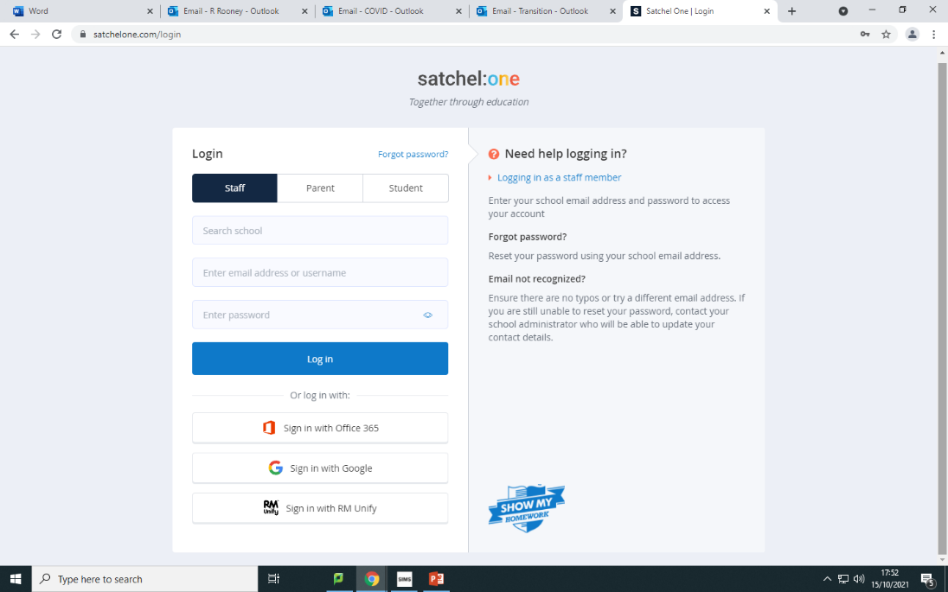

**Choose the option to ‘Sign in with Office 365’**

**You will then get a page that looks like this:**

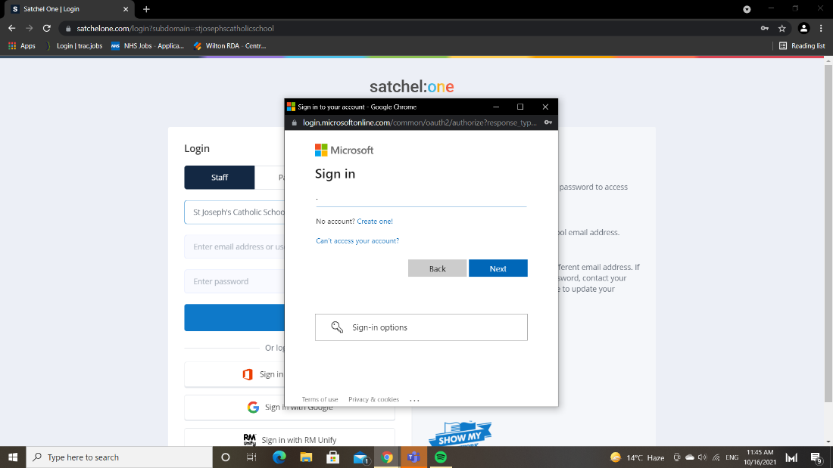

**All you need to do is put your Teams login details in and you’ll have access to SMHW! Use your school email address (**[**firstname.surname@sjcs.org.uk**](mailto:firstname.surname@sjcs.org.uk)**) and then add, when prompted, add the password you use to login at school .**